SIMATS ENGINEERING

ASSESSMENT TOOL 2

COURSE NAME: Cryptography and Network Security COURSE CODE: CS A5113

COURSE OUTCOME COVERED

CO1: Apply classical encryption techniques using symmetric and asymmetric ciphers to encrypt and decrypt data for the ensuring data security. (BL3, BL4)

Assessment Tool Weightage: 20%

QUESTIONS: 5 Total Marks: 100

Annexure A

CONCEPT MAPPING

Code of Conduct:

I SARU HASINI.S (192521418) certify that this submission is my original work and that I have adhered to the guidelines specified for this assessment.
I understand that any violation of academic integrity rules will result in disciplinary action.

Signature of the student:
SARU HASINI.S

Q. No | Understanding of Concepts  (25) | Experimental Design (30) | Use of Tools  (20) | Analysis of Results (15) | Documentation  (10) | Total Score (out of 100)
1 | / 5 | / 6 | / 4 | / 3 | / 2
2 | / 5 | / 6 | / 4 | / 3 | / 2
3 | / 5 | /6 | / 4 | / 3 | / 2
4 | / 5 | / 6 | / 4 | / 3 | / 2
5 | / 5 | / 6 | / 4 | / 3 | / 2
 |  | OVERALL RUBRICS VALUE
 | / 5 | / 5 | / 4 | / 4 | / 2
 | / 25 | / 30 | / 20 | / 15 | / 10 | / 100
Annexure A

CONCEPT MAPPING
- Create a concept map linking the following: Security Attacks, Threats, Risks and Security Goals (Confidentiality, Integrity, Availability. Perform the following tasks:
  - Show how each attack leads to specific threats and risks
  - Map how security goals help mitigate them Provide one real-world example for each link

- Develop a concept map comparing substitution techniques: Caesar Cipher, Monoalphabetic Cipher, Vigenère Cipher and Hill Cipher. Perform the following tasks to connect based on: Key usage, Complexity and Security strength. Analyze which technique is most secure and why.

- Construct a concept map for Classical Encryption Schemes: Substitution Techniques and
Transposition Techniques. Perform the following tasks:
a. Show differences and similarities
i. Map how each affects the Data structure and Security level ii. Analyze which is more vulnerable to attacks and why

- Create a concept map connecting Steganography concepts: Data Hiding, Watermarking and
Survivability. Perform the following tasks:
  - Show relationships between these concepts
  - Analyze how each contributes to secure communication
  - Include one real-world application for each

- Draw a concept map linking number theory concepts used in cryptography: Modular Inverse, Extended Euclid Algorithm, Fermat’s Little Theorem, Euler’s Phi Function and Euler’s Theorem. Perform the following tasks:
  - Show how each concept is mathematically connected
  - Map their role in encryption/decryption
  - Analyze which concept is most critical for public key cryptography and justify

RUBRICS FOR CALCULATION:
Criteria | Weightage | Level 4 –  Exemplary | Level 3 –  Proficient | Level 2 –  Developing | Level 1 –  Beginning
Understanding of Concepts | 25 | Demonstrates thorough understanding and  effectively integrates multiple concepts/technologies | Good understanding with proper  integration of most concepts | Basic understanding;  limited or partial integration | Poor understanding; unable to integrate concepts
Experimental Design | 30 | Well-planned, systematic implementation with optimal solution | Correct implementation with minor issues | Basic implementation with errors or inefficiencies | Incorrect or incomplete implementation
Use of Tools | 20 | Effective and advanced use of tools/technologies with proper configuration | Appropriate use of tools  with correct execution | Limited or inconsistent use of tools | Incorrect or minimal use of tools
Analysis of Results | 15 | Insightful analysis with accurate interpretation and validation of results | Good analysis with reasonable interpretation | Basic analysis with limited insights | Poor or incorrect  analysis of results
Documentation | 10 | Clear, well-structured documentation with  diagrams, code, and  results | Organized documentation with necessary details | Basic documentation  with missing details | Poor or incomplete documentation

ANSWERS :

- Security Attacks → Threats → Risks → Security Goals (CIA)

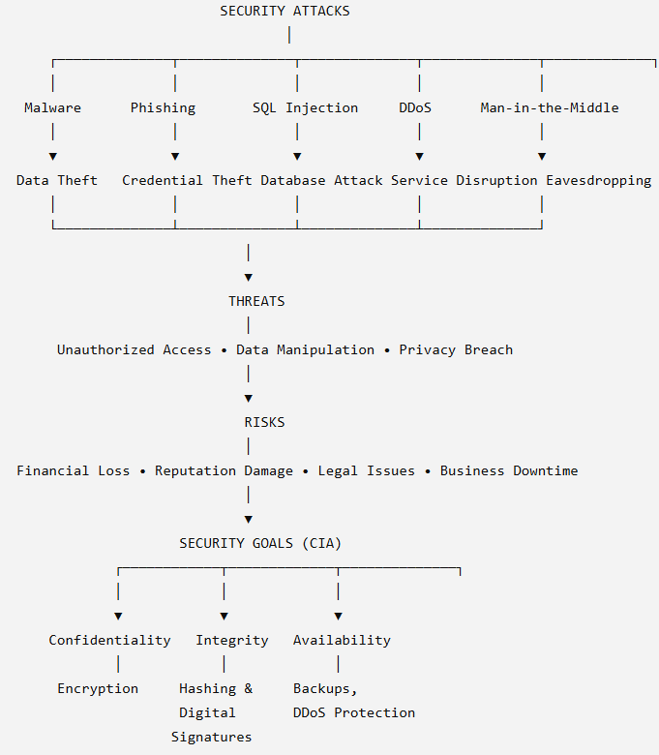

- Substitution Techniques Concept Map

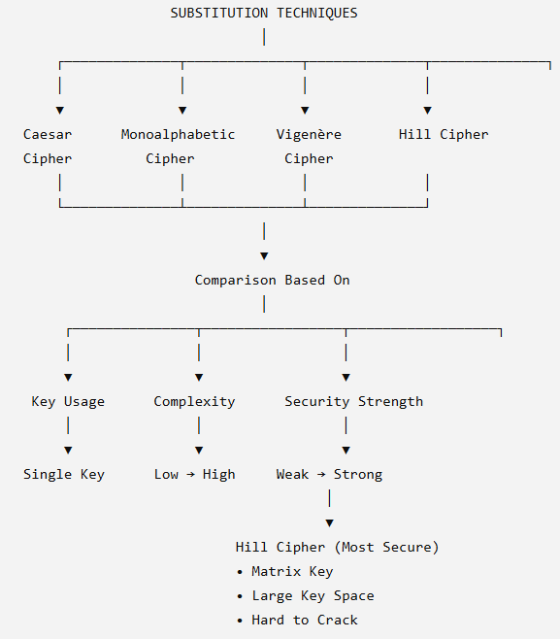

- Classical Encryption Scheme

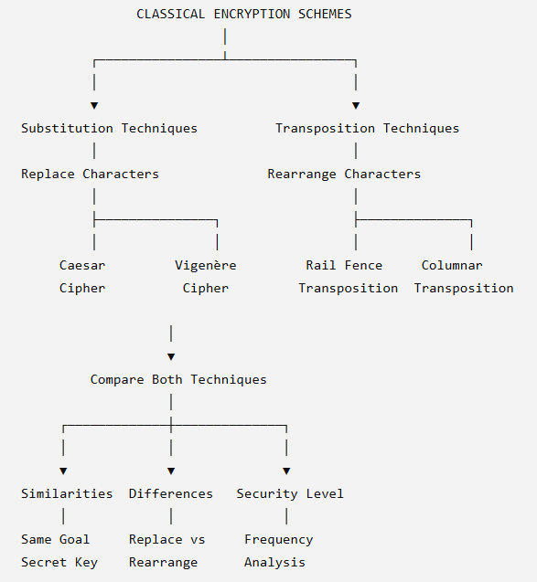

- Steganography Concept Map

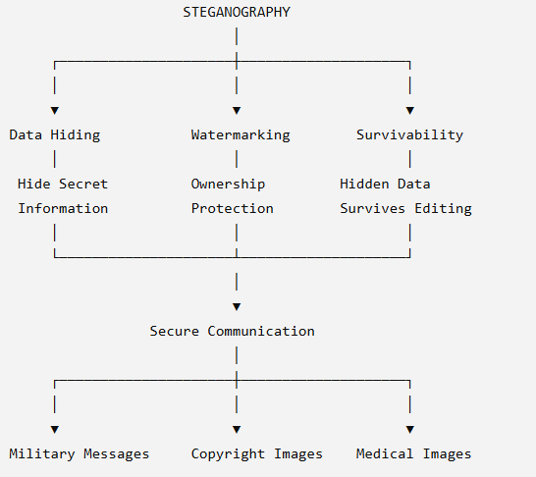

- Number Theory in Cryptography

